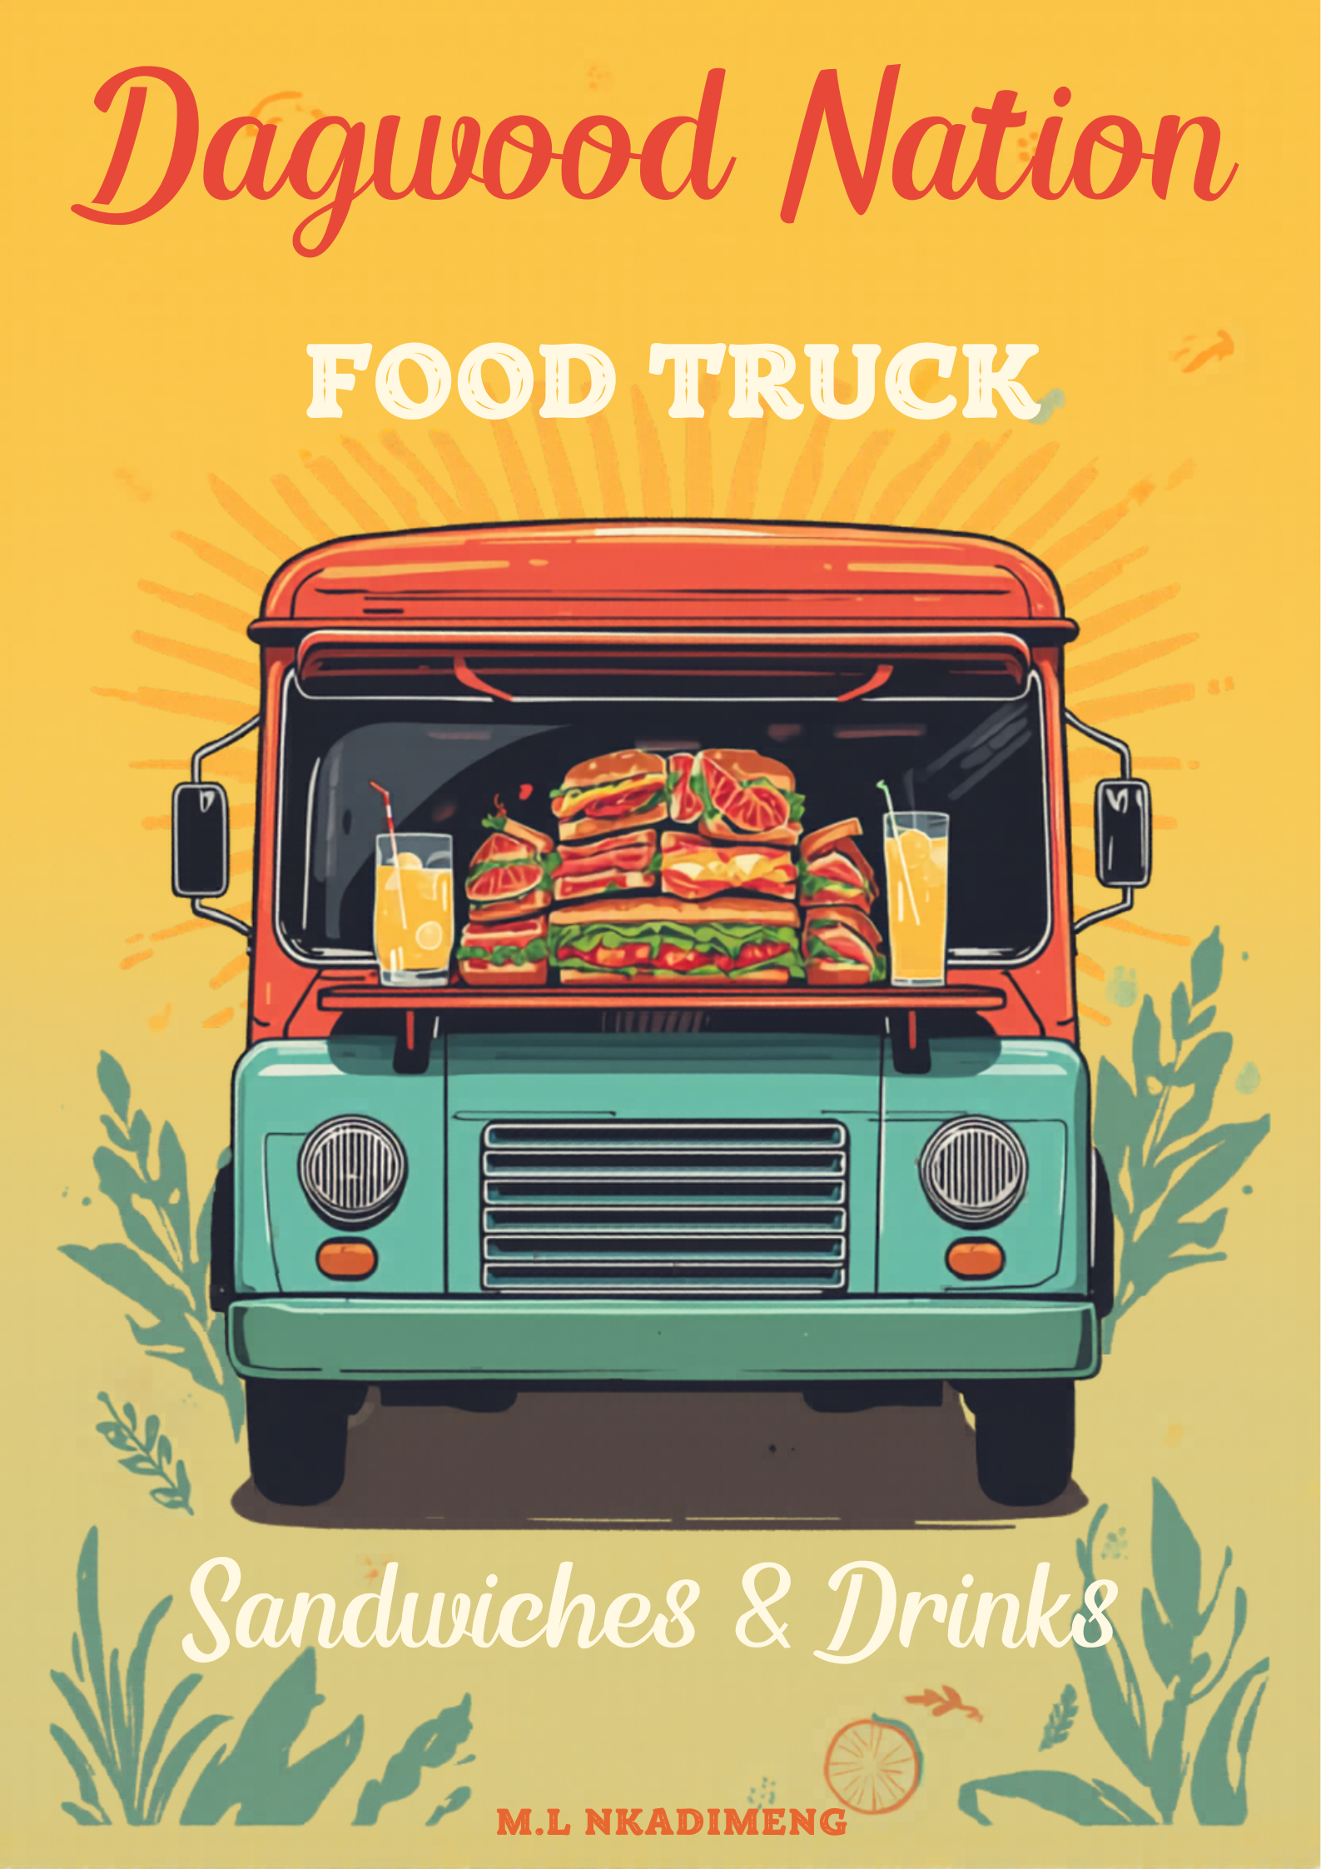

Business Proposal Plan

1. Organisation Overview

Name
Dagwood Nation

Brief History of the Organisation
Dagwood Nation Food Truck was founded to offer tasty, affordable, and convenient street food to the local community. The concept for the business stemmed from a love for making satisfying meals that people can enjoy while on the move. The food truck specializes in popular street foods like Dagwood’s, crispy chips, spiral potatoes, and refreshing beverages.
The goal of the business is to foster a fun and inviting atmosphere where customers can savour high-quality food that is freshly made and bursting with flavour. By merging excellent taste, good service, and a lively street food experience, Dagwood Nation aspires to establish itself as a well-regarded and reliable food truck brand within the community (food and hospitality Asia, 2025)

Mission Statement
Our mission is to make street food tasty, fresh, and reasonably priced while also providing outstanding customer service and making every customer's dining experience joyful.

Vision Statement
Our vision is to become a recognised and trusted street food brand known for quality meals, friendly service, and a unique street food experience, with the potential to expand into multiple food trucks.

Target Audience
The target audience includes:
- Students
- Young professionals
- Families
- Event attendees
- Street food lovers
- People looking for quick, affordable meals.

2. Website Goals and Objectives

Goals
The website will aim to:
- Promote the food truck and increase brand awareness!
- Provide information about the menu and prices!
- Inform customers about the food truck’s location!
- Allow customers to contact the business for events or catering!
- Attract new customers through online visibility!

Key Performance Indicators (KPIs)
Success of the website will be measured through:
- Number of website visitors
- Customer inquiries through the contact form
- Social media engagement
- Increased customer visits to the food truck
- Online menu views

3. Current Website Analysis (if applicable)
Since Dagwood nation Food Truck is a new business, there is currently no existing website.
However, the website will focus on the following improvements compared to typical small food business websites:

Strengths
- Clear menu presentation
- Easy-to-use navigation
- Mobile-friendly design
- Attractive food images

Areas for Improvement
Many small food businesses lack:
- Clear contact information
- Updated menus
- Online presence

4. Proposed Website Features and Functionality
The website will include the following key pages:

Homepage
- Introduction to the business
- Attractive images of food
- Featured menu items.
- Quick navigation

About Us Page
- Story of the business
- Mission and vision
- Information about the food truck

Menu Page
- List of available foods such as:
- Dagwood’s
- Chips
- Potato spirals
- Drinks
- Prices and food descriptions

Contact Page
- Contact form.
- Phone number
- Email address
- Social media links

Location Page
- Information about where the food truck will be located.
- Map or directions.

5. Design and User Experience

Colour Scheme
  (Shutterstock,2019) | 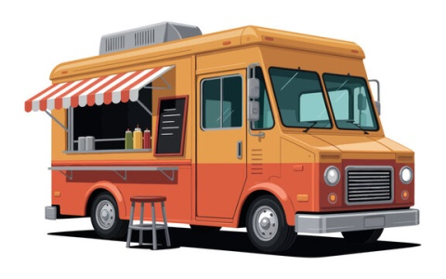  (Adobe stock,2026) | 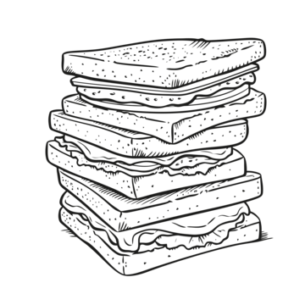  (pngtree,2026)

The proposed colour palette includes:
- Red – stimulates appetite and attracts attention.
- Yellow – represents energy and food.
- Black – creates a modern and bold look.

Typography
The website will use clear and modern fonts:
- Heading Font: Bold sans-serif font
- Body Text: Simple readable font

Layout and Design
The design will be:
- Simple and clean
- Mobile-friendly
- Easy to navigate.
- Visually appealing with food images
The homepage will highlight the main food items and provide quick access to the menu and contact information.

User Experience Considerations
The website will ensure:
- Fast loading speed
- Easy navigation
- Clear menu display
- Mobile responsiveness
- Easy contact options

Low-Fidelity Wireframes (Description)

Homepage Layout
- Logo at the top
- Navigation menu (Home | About | Menu | Contact)
- Large food image banner
- Featured menu items.
- Contact information.

Menu Page Layout
- Food categories
- Images of menu items
- Prices listed clearly

6. Technical Requirements

Domain Name
www.Dagwoodnation.co.za

Hosting
Website hosting will be required from a reliable hosting provider.
Estimated hosting providers could include:
- Afrihost
- Host Africa

Programming Languages
The website will be built using:
- HTML – structure of the website

Frameworks
Optional frameworks may include:
- Bootstrap for responsive design.

7. Timeline and Milestones
Phase | Task | Estimated Time
Week 1 | Research and planning | 2 weeks
Week 2 | Website design and wireframes | 5 weeks
Week 3 | Website development | 5 weeks
Week 4 | Testing and improvements | 6 weeks
Week 5 | Final submission and launch | 8 weeks

8. Budget Estimate
Item | Estimated Cost
Domain registration | R1500 – R2500 per year
Website hosting | R700 – R1500 per month
Website development | R2,000 – R5,000
Maintenance | R500 per year

Total Estimated Cost
Estimated cost to be R42 500 – R60 500 for the first year

Reference list

Adobe stock, 2026. Retro Orange Food Truck with Striped Awning and Menu Board Illustration. [Image online] Available at: < https://stock.adobe.com/za/search?k=food%2Btruck%2Bclipart&asset_id=1495794260 > [Accessed 12 marches 2026].
Food and hospitality Asia, 2025. The Key to Success: Understanding Food Service Operation in the Food Industry. [Online] Available at: < https://www.foodnhotelasia.com/fha-insider/food-service-operations/#:~:text=Food%20service%20operation%20refers%20to,the%20key%20to%20staying%20ahead > [Accessed 27 October 2025].
PNG Tree, 2026. Sandwiches Outline PNG Images. [Image online] available at: < https://pngtree.com/so/sandwiches-outline > [Accessed 10 march 2026].
Shutterstock, 2019. Red yellow black colour Germany blurry gradient effect. [Image online] Available at: < https://www.shutterstock.com/image-illustration/red-yellow-black-color-germany-blurry-1388057192 > [Accessed 4 may 2019].

